**Review comments**

**Reviewer 1:**

With great interest I've read this really interesting paper on macrolide resistance genes. The authors have written a very good paper. The research has some important limitation, but the authors have all discussed them in the "discussion" session. Therefore, I have only a few less important remarks:

1. Do the authors have data or literature to support the statement in the Methods that a 6 month “wash-out” is enough to go back to a “baseline” situation?

**[Our response]**

In the methods and supplementary data (See main manuscript: page ? and line ?; Online supplement: page ? and line ?), we include the text that a macrolide non-recipient was defined as someone who had not received any macrolide therapy in the 6 months prior to enrolment in the study. We chose to set 6 months as a cut-off due to reports from previous literature. For example, Malhotra *et al.*, showed that macrolide resistance genes returned to baseline levels at 6 months (PMID: 17292768). This is further supported by a meta-analysis by Costelloe *et al.* (PMID: 20483949).

1. The authors have a 4-week wash-out for other antibiotics but how about e.g. clindamycin (Lincosamides) in this erm setting?

**[Check clinical manifest]: Done**

From the clinical manifest, none of the participants received clindamycin during the 4-week wash-out

**[Contact three clinicians]: Done**

Three clinicians have all confirmed that none of their patients received clindamycin.

**[Our draft]**

We have confirmed that all participants including patients and close contacts did not receive clindamycin during the 4-week wash-out period.

**[Our response]**

1. In the cohort overview results, the authors mention a 12-month interval used for macrolide as an exclusion but in the methods it’s 6 months. Could the authors explain this discrepancy?

**[Our response]**

We apologise for this error. To clarify, all patients in the macrolide non-recipient group had not received any antibiotic in the 6 months prior to sample collection. We have now revised the manuscript and amended any discrepancies (See main manuscript: page ? and line ?; Online supplement: page ? and line ?).

1. Could the authors give more detail on the relationship between patients and controls? Are they siblings or spouses or others? This might influence contact. I imagine that transmission risk is different between a friend you see frequently or your sibling or your partner… Do the authors have details and could this have influenced the data (e.g. more similarity between partner vs friends?)

**[Task]**

1. For missing data, contact clinicians: Done
2. Description of relationship details: Done

**[Our draft]**

We have tracked down the relationship between patients and their close contacts. A breakdown of the relationship is provided in the tables below (Table R1 and Table R2). For clarity, the relationships were categorised into three: 1) Family members including parent, siblings and children; 2) Partner, spouse or de facto 3) Friend. As these tables illustrate, 92% (86/93) of close contacts are cohabitant to patients. The table of relationship details has been included in online supplement (See online supplement, e-Table ?).

We agree that the level of close contacts may differ between these groups. The “close contact” in our study refers to those family members (parent, children and siblings), friends or partner, spouse and de facto who either is a cohabitant (>6 months) or regular contact (>2 times per week in the last 2 years) to the patients. Our study set out to address whether there was any evidence of transmission of macrolide resistance genes between patients and close contacts and whether macrolide use was associated with transmission risk. While the different degree of contact is an important consideration for the propensity of AMR transmission, such subgroup analysis is beyond the scope of this study. To emphasize the importance of different degree of contact on propensity of AMR transmission, a small discussion has been included in the revised manuscript (See main manuscript: page ? and line ?)

**Table R1.** Summary of all participants’ relationship details in this study

|  |  |  |  |
| --- | --- | --- | --- |
| **Relationship** | **Sample size** | **Details** | **Percentage**  **(%)** |
| Family members  (Parent, siblings and children) | 31 | Cohabitant  (>6 months) | 90  (28/31) |
| Regular contact  (>2 times per week in the last 2 years) | 10  (3/31) |
| Partner, spouse and de facto | 59 | Cohabitant  (>6 months) | 98  (58/59) |
| Regular contact  (>2 times per week in the last 2 years) | 2  (1/59) |
| Friend | 3 | Cohabitant  (>6 months) | 0  (0/3) |
| Regular contact  (>2 times per week in the last 2 years) | 100  (3/3) |

**Table R2.** Summary of relationship details in different treatment groups

|  |  |  |  |  |
| --- | --- | --- | --- | --- |
| **Treatment group** | **Relationship** | **Sample size** | **Details** | **Percentage**  **(%)** |
| Macrolide recipient group  (MR-MRCC) | Family members  (Parent, siblings and children) | 20 | Cohabitant  (>6 months) | 90  (18/20) |
| Regular contact  (>2 times per week in the last 2 years) | 10  (2/20) |
| Partner, spouse and de facto | 32 | Cohabitant  (>6 months) | 97  (31/32) |
| Regular contact  (>2 times per week in the last 2 years) | 3  (1/32) |
| Friend | 1 | Cohabitant  (>6 months) | 0  (0/1) |
| Regular contact  (>2 times per week in the last 2 years) | 100  (1/1) |
| Macrolide non-recipient group (MNR-MNRCC) | Family members  (Parent, siblings and children) | 11 | Cohabitant  (>6 months) | 91  (10/11) |
| Regular contact  (>2 times per week in the last 2 years) | 9  (1/11) |
| Partner, spouse and de facto | 27 | Cohabitant  (>6 months) | 100  (27/27) |
| Regular contact  (>2 times per week in the last 2 years) | 0  (0/27) |
| Friend | 2 | Cohabitant  (>6 months) | 0  (0/2) |
| Regular contact  (>2 times per week in the last 2 years) | 100  (2/2) |

**Reviewer 2:**

Wang and colleagues seek to assess whether long-term macrolide therapy poses a risk for onward transmission of resistance genes in patients with chronic respiratory disease and their co-inhabitants. Though limited in scope (focusing on a select number of macrolides + tetracycline genes by qPCR), I can’t fault the technical execution of the molecular methods presented. I have some concerns about the experimental design, analysis, and conclusions.

1. That the relative abundance of ermB is higher in MR and MNR group. However, they also tested 9 additional resistance genes (multiple hypothesis testing) and I don’t see where this has been adjusted for. With adjustment, significance will probably be lost.

**[Pre and post FDR results]: Done**

**[Our response]:**

Below we provide the outcome tables without and with FDR adjustment (Benjamini and Hochberg method) using the “stats” package in R (PMID: 30124010). As Table R4 shows, difference in *erm*(B) levels between MR and MNR group is not significant after FDR adjustment. We have amended the manuscript to reflect this outcome (See main manuscript: page ? and line ?).

Explanation of Type I and Type II error

Type I and Type II errors form an inverse of relationship; when one goes down, the other goes up and vice-versa. Depending on the correlation structure of the tests, the correction methods are quite conservative which may lead to a relative high rate of false negative rates. Therefore, we did not perform FDR adjustment in the first place. However, we agree that controlling Type I errors is extremely important especially when researchers perform multiple testing. Given that 10 tests were performed, the probability of at least 1 false positive result is 0.41 (*P*[making at least 1 error in m tests]=1-(1-α)m). In our revised manuscript, we have included post-FDR *P* value in all tables (See main manuscript: page ? and line ?).

Our conclusion is in support of previous findings

The novelty of this study was the comparison between patients and close contacts

**Table R3.** Resistance gene detection frequency in patients stratified by macrolide use.

|  |  |  |  |  |
| --- | --- | --- | --- | --- |
| **Resistance gene** | **MR** | **MNR** | ***P* values** | ***P* values**  **(post-FDR)** |
| *erm*(A) | 3.8%  (2/53) | 5.0%  (2/40) | 0.99 | 0.99 |
| *erm*(B) | 89%  (47/53) | 95%  (38/40) | 0.46 | 0.66 |
| *erm*(C) | 19%  (10/53) | 13%  (5/40) | 0.57 | 0.71 |
| *erm*(F) | 68%  (36/53) | 78%  (31/40) | 0.36 | 0.62 |
| *mef* | 74%  (39/53) | 83%  (33/40) | 0.33 | 0.62 |
| *msr*(A) | 36%  (19/53) | 25%  (10/40) | 0.37 | 0.62 |
| *msr*(E) | 66%  (35/53) | 73%  (29/40) | 0.65 | 0.72 |
| *tetM* | 94%  (50/53) | 100%  (40/40) | 0.26 | 0.62 |
| *tetO* | 64%  (34/53) | 78%  (31/40) | 0.18 | 0.62 |
| *tetW* | 85%  (45/53) | 98%  (39/40) | 0.07 | 0.62 |

**Table R4.** Normalised resistance gene abundance in patients stratified by macrolide use.

|  |  |  |  |  |
| --- | --- | --- | --- | --- |
| **Resistance gene** | **MR** | **MNR** | ***P* values** | ***P* values**  **(post-FDR)** |
| *erm*(A) | 0  (0.0-10.5) | 0  (0.0-7.1) | 0.39 | 0.99 |
| *erm*(B) | 7.5  (0.0-12.4) | 6.9  (0.0-10.8) | 0.045* | 0.66 |
| *erm*(C) | 0  (0.0-13.2) | 0  (0.0-8.0) | 0.14 | 0.71 |
| *erm*(F) | 7.6  (0.0-12.4) | 6.2  (0.0-11.9) | 0.22 | 0.62 |
| *mef* | 4.4  (0.0-6.7) | 3.9  (0.0-7.5) | 0.20 | 0.62 |
| *msr*(A) | 0  (0.0-13.2) | 0  (0.0-9.1) | 0.15 | 0.62 |
| *msr*(E) | 7.3  (0.0-13.0) | 5.7  (0.0-15.9) | 0.07 | 0.72 |
| *tetM* | 5.9  (0.0-8.9) | 5.5  (2.1-7.6) | 0.42 | 0.62 |
| *tetO* | 6.4  (0.0-10.5) | 6.3  (0.0-12.3) | 0.39 | 0.62 |
| *tetW* | 5.2  (2.7) | 4.8  (2.2) | 0.46 | 0.62 |

* indicates the significance of this comparison lost after FDR correction

**Table R5.** Paired assessment of the resistance gene detection frequency between patients and close contacts stratified by macrolide use.

|  |  |  |  |  |  |  |
| --- | --- | --- | --- | --- | --- | --- |
| **Resistance gene** | **MR vs MRCC** | | | **MNR vs MNRCC** | | |
| **Odds ratio**  **(95% CI)** | ***P* value** | ***P* values**  **(post-FDR)** | **Odds ratio**  **(95% CI)** | ***P* value** | ***P* values**  **(post-FDR)** |
| *erm*(B) | 3.4  (0.5-22.9) | 0.21 | 0.38 | 1.3×10-7  (0-Inf) | >0.99 | 0.99 |
| *erm*(C) | 5.1  (0.6-41.9) | 0.13 | 0.29 | 8.5  (0.4-163.9) | 0.16 | 0.99 |
| *erm*(F) | 11.8  (2.3-59.6) | 0.0029† | 0.020 | 1.7  (0.4-7.6) | 0.50 | 0.99 |
| *mef* | 7.3  (1.9-28.4) | 0.0044† | 0.020 | 1.3  (0.3-6.9) | 0.75 | 0.99 |
| *msr*(A) | 1.5  (0.5-4.9) | 0.48 | 0.62 | 1.8  (0.4-8.2) | 0.43 | 0.99 |
| *msr*(E) | 0.8  (0.3-2.7) | 0.74 | 0.83 | 1.1  (0.3-4.5) | 0.87 | 0.99 |
| *tetM* | 2.1×10-7  (0-Inf) | >0.99 | 0.99 | N/A | N/A | N/A |
| *tetO* | 2.7  (0.8-8.5) | 0.099 | 0.29 | 1.7  (0.4-7.6) | 0.50 | 0.99 |
| *tetW* | 2.4  (0.5-12.0) | 0.29 | 0.44 | 2.5×10-7  (0-Inf) | >0.99 | 0.99 |

† indicates the significance of this comparison remained after FDR correction

**Table R6.** Assessment of long-term macrolide use on onward transmission risk of macrolide resistance genes.

|  |  |  |  |
| --- | --- | --- | --- |
| **Resistance**  **gene** | **Macrolide recipient group vs Macrolide non-recipient group** | | |
| **Odds ratio**  **(95% CI)** | ***P* value** | ***P* values**  **(post-FDR)** |
| *erm*(A) | 1.0  (0-Inf) | >0.99 | 0.99 |
| *erm*(B) | 1.0  (0.4-2.9) | 0.96 | 0.99 |
| *erm*(C) | 1.0  (0.07-13.9) | >0.99 | 0.99 |
| *erm*(F) | 1.0  (0.4-2.5) | 0.97 | 0.99 |
| *mef* | 1.6  (0.6-3.9) | 0.33 | 0.99 |
| *msr*(A) | 1.3  (0.3-5.0) | 0.73 | 0.99 |
| *msr*(E) | 0.6  (0.2-1.5) | 0.25 | 0.99 |
| *tetM* | 0.5  (0.09-2.7) | 0.43 | 0.99 |
| *tetO* | 0.9  (0.4-2.2) | 0.82 | 0.99 |
| *tetW* | 0.7  (0.3-2.0) | 0.55 | 0.99 |

(1)“Onward transmission” of resistance genes, i.e. (that is) increased relative risk of resistance gene co-detection in co-habitants of patients on long-term macrolide therapy.

(2) However, onward transmission is somewhat speculative since it is not really possible to establish “transmission” of a resistance gene by the methodology employed. A patient could have acquired the resistance gene from their co-inhabitant initially for example. We are really looking at the effect of “household antibiotic use” on risk of resistance detection in untreated individuals. The word transmission is misleading.

(3) One would need to isolate a resistant organism from both patient and co-inhabitant and test this by strain typing or WGS analysis (as a start).

**[Our response]:**

1. Household transmission are present and important (ref)
2. Onward transmission not only limit to co-detection of genes, but also the relative abundance of the genes, our study analysed both and compared with control group (non-macrolide group)
3. We agree that a patient could acquired the genes from co-inhabitant initially, but
   1. We have strict wash-out period (see response in reviewer 1)
   2. Macrolide therapy plays the major role in macrolide resistance development (abundance)
   3. Onward transmission not only assess the co-detection, but also compare the abundance with control group/with patient group
4. WGS?

**[AMR dissemination papers]: Evidence of Household transmission of antibiotic resistance**

1. Mughini-Gras 2019- PMID 31439317: Humans to human transmission are the main source of community acquired antibiotic-resistant bacteria
2. Examples of antibiotic resistance (bacteria) transmission (MRSA):
   1. PMID11101914: household contacts (27/87, 31%) vs the community (14/77, 18.1%)
   2. PMID19923490: two-thirds (67%; n = 56) of household contacts -> MRSA positive

(1)“Carriage and transmission of resistance genes” For macrolides, this is an incredibly difficult question to address by the applied methodology given the apparently high prevalence of macrolide resistance in the environment/microbiome.

(2)Macrolide and Tetracycline resistance genes are frequently the most highly detected resistance genes reported in resistome studies. Thus, even healthy individuals may harbour these genes anyway, perhaps through maintenance via other, as yet unrecognised, selective pressures.

(3)There seem to be many unanswered questions that the study fails to address. Just looking at a few resistance genes at a single anatomical site is somewhat limited in scope considering the complex effects of antibiotics on the microbiome/resistome.

**[Our response]**

1. **Global macrolide/tetracycline resistance:** 31.0% (pneumococcal macrolide resistance, PMID: 15963272), 8.7% and 24.3% (Tetracycline for MRSA and S, pneumoniae, PMID: 26989065)
   1. Most of these resistance studies above collected samples from patients, not healthy individuals
2. **Macrolide use drives macrolide resistance:** Macrolide use is the most important driver of macrolide resistance (PMID: 17292768-Malhotra, PMID: 29669883, PMID: 23532241, PMID: 17195698, PMID: 16469851)
3. **Household transmission is important:** Humans to human transmission are the main source of community acquired antibiotic-resistant bacteria (PMID 31439317) and transmission risk of MRSA is higher among household contacts than among community members (PMID 11101914)
4. **In this study, we not only assessed the carriage but also assessed the abundance**

**In Australian population, the macrolide carriage rate is lower than many other countries:** In Australia, 32.4% carried ermB, this rate is not high as compared with other countries (e.g, Morocco 90.2%, Belgium 90.2%, France 90.0%, Poland 80.8%) (PMID: 27709102)

**[Find 2-3 papers that describe the global frequency of macrolide and tet resistance genes]**

**Reference**

**Prevalence of macrolide resistance gene in global (**PMID:27709102)

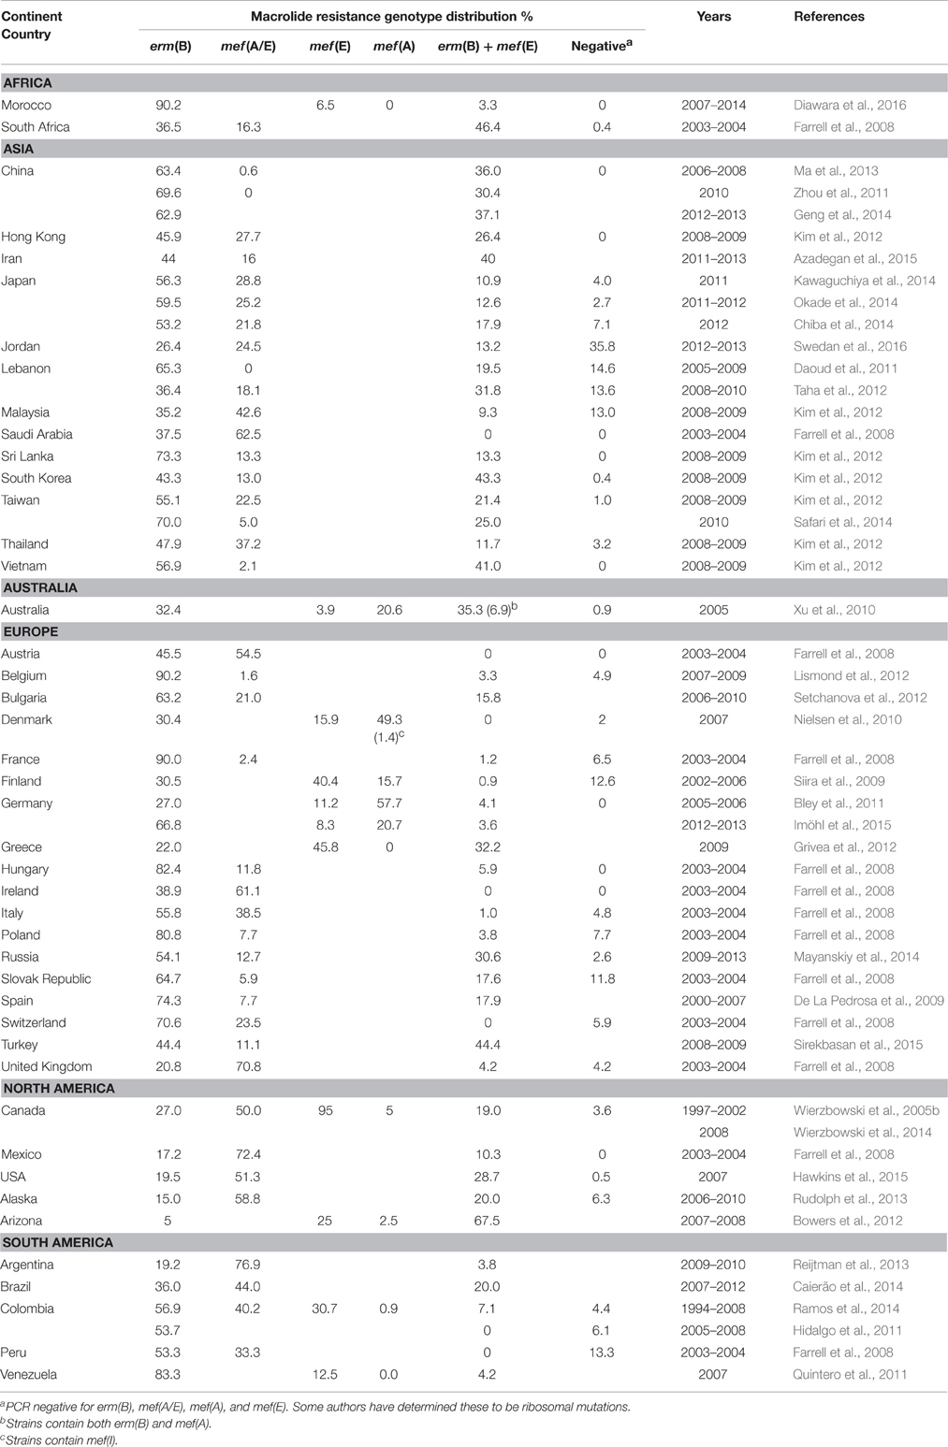

That “long-term term antibiotic macrolide therapy was not associated with increased risk of acquiring macrolide resistance genes”.

A major shortcoming is that only macrolide/tetracycline resistance was assessed.

Macrolide exposure can co-select for other resistance genes which may be an even greater concern (thinking of MDR plasmids etc.).

**[Our response]**

**[Preparation]**

1. Tet genes are found on plasmids
2. Describe how you identified these genes
3. The positioning of this study focused on macrolide exposure on macrolide resistance
4. ermA/B/C/F, msrA/E and mef are six common macrolide resistance genes that are carried on mobile genetic elements (ref)
5. Why tet included:
   1. tetM and tetO were found on the same mobile genetic elements with macrolide resistance gene (Tn5358, Tn1545 for tetM, Tn2009 for tetO, PMID: 12936983, PMID: 15837373-tetO, PMID: 7648031-tetM)
   2. tetW was recently found to be strongly associated with macrolide therapy (Steven’s paper, PMID: 30875247)

Given that, macrolide resistance acquisition might restrict the use of not only all macrolides, but also tetracyclines.

Further, the lung microbiome is relatively stable under antibiotic treatment and the gut is less so. The impact of macrolides on the gut may be much more relevant in terms of potential transmission of resistance.

I understand that the focus is on the airway but what happens in the gut seldom stays in the gut, where resistance is concerned.

**[Preparation]**

1. matergut

**Steven’s matergut paper:**

**[Our response]**

1. We agree that resistance in the gut is also important; however,
   1. Our recent paper already compared the fecal resistomes between adult CF and healthy individual (PMID: 33250435)
   2. This study focused on the airway resistance transmission; however, we agree that resistance in the gut is also important
2. A small discussion on the importance of potential transmission of resistance in the gut is included in the revised manuscript (See main manuscript: page ? and line ?)

In summary, the authors assess the impact of antibiotic therapy on macrolide/tetracycline resistance gene carriage/transmission in the airway and fail to detect a convincing signal that might suggest this is a real clinical problem.

However, the study completely overlooks both other (non-macrolide/tetracycline) resistance mechanisms as well as the selective pressures placed on the intestinal microbiome and the risk of transmission of resistant gut pathogens. The authors have not sufficiently assessed this element and I’m concerned that it conveys a false message e.g. “macrolide selection is probably a non-issue”.

Antibiotic selection in the gut (initially on commensal species) likely preceded the global dissemination of cephalosporinase resistance genes (i.e. CTX-M-15), for example. The effect of antibiotic selection in the airway and corresponding impact on AMR dissemination has yet to be concussively investigated. Thus, not looking at the gut, in the context of an AMR study is an oversight if onward transmission is the focus. Further the narrow range of analysis (10 genes) in the lung is a concern. Many other relevant resistance events could have been missed.

**[Preparation]**

# Point to the strength of the study (Cover letter could help)

As we mentioned in our manuscript:

1. This study is the first cross-sectional cohort study that report the impact of long-term macrolide therapy on oropharyngeal macrolide resistance gene carriage in healthy close contacts of people with chronic lung diseases
2. It mainly focused on evaluating the impact of long-term macrolide therapy on airway macrolide resistance genes development and potential onward transmission risk of these genes to the close contacts
3. To assess the impact of long-macrolide therapy on airway macrolide resistance genes development, a total of 93 people with chronic respiratory conditions (53 receiving long-term macrolides, 40 macrolide naïve) were included, and we analysed the carriage and abundance of 7 common macrolide resistance gene and 3 macrolide-related genes
4. To explore the potential risk for onward transmission, 93 paired samples from close contacts of subjects were collected and were subjected to three analyses: 1) by comparing resistance between close contacts of macrolide recipients and non-recipients 2) by comparing detection rates within groups 2) by comparing transmission risk between macrolide recipient and non-recipient groups
5. We found that long-term macrolide exposure is associated with increased macrolide resistance carriage within patients (before FDR), however, importantly, no increase in resistance carriage was observed in close contacts of patients. These findings support the continued safe use of macrolide maintenance therapy in chronic respiratory disease.
6. Limitation of this study is also well-described in the discussion section
7. Taken together, we think this study is

**[Our responses]**

**Reviewer 3:**

The authors address the issue of whether long term macrolide therapy increases macrolide resistance and whether macrolide resistance increases in close contacts. There are a number of papers showing increased macrolide resistance and resistance genes with macrolide use, so the novelty lies in the issue of whether this spread.

1. I am not sure that clinical readers will understand the difference between gene detection and gene abundance, and perhaps some mention of qualitative vs quantitative or presence/absence vs total amount is appropriate for readers not familiar with microbiome work.

**[Preparation]**

* We recognise this issue
* It is a complex issue where both contribute to our understanding
* We define these as … Within the author team, we have discussed this at length
* In response, we have [included definitions of each term]

Change to presence/absence and quantitative? Or stick to our original terms but define them both in text and in abbreviation list?

**[Our responses]**

1. For a clinical journal I think you need to put your data into a clinical context - what does all this mean in terms of clinically significant resistance in bacteria that would normally be treated by an oral macrolide (the real concern about community macrolide resistance). especially S.pneumoniae and other common streptococci.

**[Preparation]**

* For discussion with Rachel and Lucy’s

1. There is no comment about whether the close contacts had administration of macrolides within a reasonable period (say 12 months) of sampling. With not vast numbers, this is a potential confounding variable.

**[Preparation]**

* we included in online supplement

* This is an important feature of the study

* we have now moved this to the main text

**[Our responses]**

Thanks for pointing this issue.

In our initial submission version, we include this information in the study design section and in the online supplement material. For clarity, all close contacts have not received any macrolide in the prior 6 months. We chose to set 6 months as a cut-off due to reports from previous literature. For example, Malhotra *et al.*, showed that macrolide resistance genes returned to baseline levels at 6 months (PMID: 17292768). This is further supported by a meta-analysis by Costelloe *et al.* (PMID: 20483949).

We strongly agree that this is an important feature of this study. To make the subject inclusion and exclusion criteria clearer to the audience, we have now moved this to the main text (See main manuscript: page ? and line ?)

1. With respect to the key issue of "does this resistance transfer to others, the key issue is whether the sample size is adequate to reach the conclusion of "no it doesn't". It is not defined what you would have considered sufficient gene transfer of resistance to be clinically or even epidemiologically relevant.

**[Preparation]**

* Incidence where there was evidence of transmission (e.g. 2/53 times).:

* HOW MANY TIMES DID “TRANMISSION” OCCUR

1. Definition of co-carriage and transmission
   1. Co-carriage/dependency: incidence of 1-1 and 0-0 vs incidence of 0-1 and 1-0
   2. Transmission: incidence of 1-1 vs incidence of 0-1 and 1-0
2. How many times did transmission occur?

**[Tables]**

**Table R7.** Incidence of transmission

|  |  |  |
| --- | --- | --- |
| **Resistance gene** | **Macrolide group**  **(Percentage, %)** | **Non-macrolide group**  **(Percentage, %)** |
| *erm*(A) | 0  (0/53) | 0  (0/40) |
| *erm*(B) | 77  (41/53) | 80  (32/40) |
| *erm*(C) | 4  (2/53) | 3  (1/40) |
| *erm*(F) | 42  (22/53) | 53  (21/40) |
| *mef* | 55  (29/53) | 53  (21/40) |
| *msr*(A) | 15  (8/53) | 10  (4/40) |
| *msr*(E) | 23  (12/53) | 35  (14/40) |
| *tet*(M) | 91  (48/53) | 95  (38/40) |
| *tet*(O) | 45  (24/53) | 53  (21/40) |
| *tet*(W) | 68  (36/53) | 78  (31/40) |

**[Our responses]**

Given you did show erm and mef detection was more common in contacts of macrolide users, I am not clear at all how you can justify your conclusion that resistance is not trasnmissable into the community - in fact the opposite finding would appear to be supported by your data - as you acknowledge in your discussion.

The last sentence of the abstract is therefore far too strong and not supported by your data.

**[Preparation]**

**A figure to explain this ?**

1. Two models were employed to assess co-carriage (dependency) and transmission risk
   1. Revise discussion part as we confuse others about the first model?
2. The first model is within group comparison, the second model is between group comparison
   1. Our first analysis model focus on the co-carriage of resistance genes in each treatment group (incidence of 1-1 and 0-0 vs incidence of 0-1 and 1-0)
   2. Our second analysis model focus on the impact of macrolide therapy on transmission risk (Presence/absence of treatment (1/0) effect on transmission (1-1) and no transmission (0-1 and 1-0))
3. The significance of ermF and mef that found in the first model is not an indication of macrolide effects on transmission risk, this is because
   1. The first model aims to evaluate whether the resistance gene in close contacts is dependent/independent of that in patients in each treatment group, thus, 0-0 pairs were also included and considered as dependent pairs; however, 0-0 pairs can not be counted as transmission evidence
   2. Two treatment groups were subjected to the first model separately. Statistically speaking, P values cannot be compared directly
4. Our conclusion is:
   1. However, macrolide use was not associated with increased macrolide resistance gene detection rate and there was no evidence that long-term macrolide use increases the onward transmission risk to their close contacts
   2. It is appropriate because
5. In the discussion I think you have to note that the community data you have is an Australian context. Australia has seen much less use of oral macrolides, and especially problematic ones like Azithromycin, than has, for example, the US and hence international surveillance data typically shows much less clinical macrolide resistance in your population.

**[Preparation]**

# Get statistics: Done

**[Our response]**

* We agree that the community data you have is an Australian context, we had revised our manuscript and made it clear the conclusion drawn in this study was based on Australian population
* A discussion of macrolide usage especially Azithromycin is included in the discussion section

**[Data]**

DDD: Defined daily dose

1. **Australia:**

Unit: DDD per 1,000 occupied bed days

***Source 1:*** *Australian Commission on Safety and Quality in Health Care. AURA 2021: fourth Australian report on antimicrobial use and resistance in human health. Sydney: ACSQHC; 2021.*

* 1. Macrolides: **~2.3** DDD/1 000 inhabitants/per day in 2017 drop to **~1.8** in 2019
  2. Azithromycin:
     1. the rate of inappropriate prescription of all azithromycin prescription is huge 26.5% (n=891)
     2. There was a huge rise in the proportion of private prescriptions for azithromycin throughout the 10-year period. To support this view, average monthly private prescriptions of azithromycin were 423 in 2010 (0.07 per 100 GP visits), increasing to 1,424 in 2019 (0.16 per 100 GP visits).
     3. there was a slight increase in the overall rate of PBS prescribing of antimicrobials that have restricted benefits with azithromycin increasing from 0.84 to 1.1 per 100 prescriptions
     4. Top 10 most commonly prescribed antimicrobials in NAUSP (National Antimicrobial Utilisation Surveillance Program) contributor hospital

1. **Europe:**

Unit: DDD per 1 000 inhabitants per day

***Source:*** *European Centre for Disease Prevention and Control. Antimicrobial consumption in the EU/EEA (ESAC-Net) - Annual Epidemiological Report 2020. Stockholm: ECDC; 2021.*

J01F: Macrolides, lincosamides and streptogramins

* 1. Community usage:
     1. 2020: **2.39** DDD/1 000 inhabitants/ per day (compound annual growth rate -4%)
  2. Hospital usage:
     1. During 2011-2020: No significant EU/EEA trends were detected for consumption of macrolides, lincosamides and streptogramins (ATC group J01F).
     2. 2020: **0.17** DDD/1 000 inhabitants/ per day (compound annual growth rate 3.9%)

1. **USA: Although the WHO promotes the use of DDDs as metrics of drug use, but America do not**

Source: CDC antibiotic resistance & Patient Safety Portal

1. In 2020, 88 prescriptions of macrolides were dispensed in U.S. outpatient pharmacies for every 1,000 persons.
2. In 2020, 29 million prescriptions of macrolides were dispensed in U.S.outpatient pharmacies.

Source: https://clincalc.com/DrugStats/Drugs/Azithromycin

1. 2019: 3.62 prescriptions/1 000 patients/per day (calculated by myself)
2. **Other countries/region have higher macrolide usage (>15%)**

Unit: DDD per 1 000 inhabitants per day and proportion of total consumption

***Source:*** *WHO report on surveillance of antibiotic consumption: 2016-2018 early implementation. Geneva: World Health Organization; 2018. Licence: CC BY-NC-SA 3.0 IGO.*

1. Region of the Americas: Canada 3.29 (19.3%)
2. Region of Eastern Mediterranean Region: Jordan 4.66 (52.2%)
3. Region of Western Pacific Region: Japan 4.59 (32.3%), Republic of Korea 4.69 (17.0%)

Australia

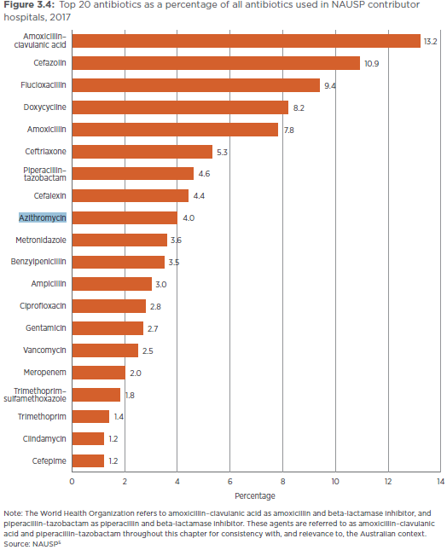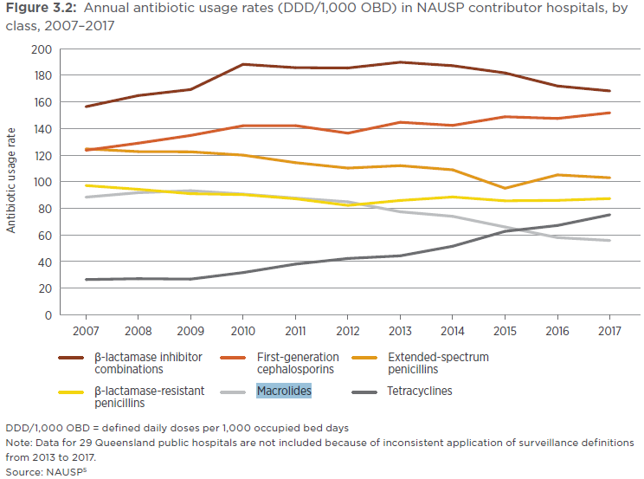

Europe

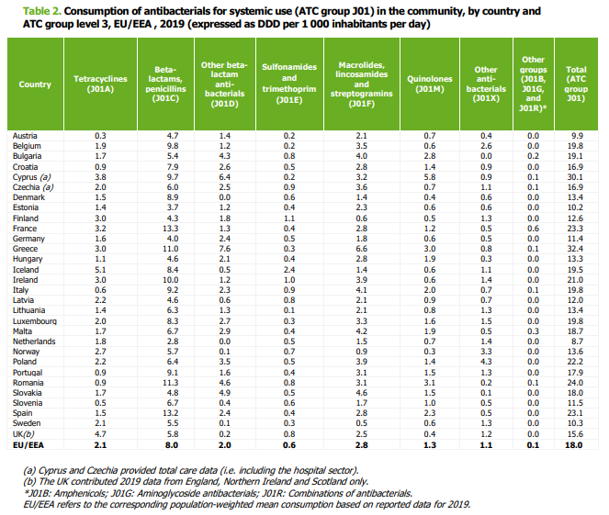

USA

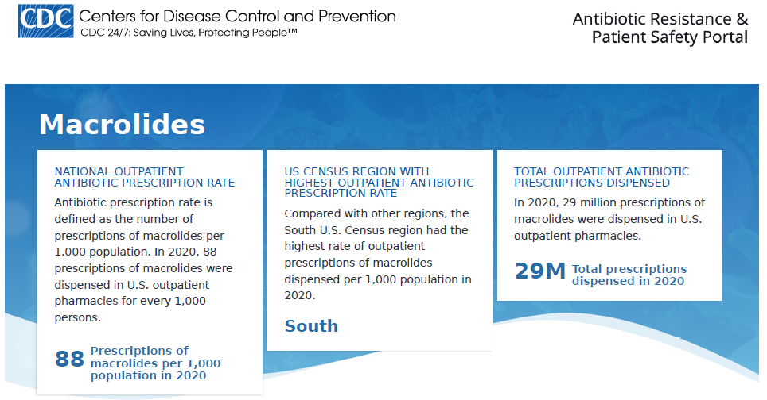

(1)Very few of the close contact groups had any significant chronic lung disease. Do you think this may exert a protective effect on macrolide resistance transfer because they will not have as disordered a microbiome?

(2)We know that CF and bronchiectasis patients can and do transfer multi-resistant organisms to each other, but not to healthy contacts. This should at least be reflected on in the discussion.

**[Preparation]**

**Statistical Review Comments:**

The primary objective of this prospective study is to estimate and compare macrolide resistance gene detection rates and abundances between MR, MNR, MRCC, and MNRCC cohorts. Study design, data collection, primary endpoints, and statistical methods were clearly described. Logistic regression models were used to associate cohorts with detection and transmission status. Results were presented adequately and clearly. Conclusions were drawn appropriately. I have one minor suggestion (not a concern or question):

1. Seems authors could try logistic GEE model to estimate and compare 4 cohorts (MR, MNR, MRCC, and MNRCC) in one model with respect of resistant genes detection. This would be more efficient than first comparing within treatment pairs then between treatment groups.

**[Preparation]**

1. Background:
   1. The GEE logit estimates the same model as the standard logistic regression (appropriate when you have a dichotomous dependent variable and a set of explanatory variables). Unlike in logistic regression, GEE logit allows for dependence within clusters, such as in longitudinal data, although its use is not limited to just panel data
   2. it’s a marginal model. GEE computations are usually easier than mixed-effect model computations. GEE does not use the likelihood methods that mixed-effect models employ, which means GEE can sometimes estimate more complex models.

Bin

1. **Mughini-Gras 2019:** Humans to human transmission are the main source of community-acquired β-lactam-resistant E.coli
   1. Most community-acquired β-lactam-resistant E.coli carriage was attributed to human-to-human transmission within or between households in the open community (60·1%, 95% credible interval 40·0–73·5)
2. **Knox 2015_Trends in microbiology:** Several studies have highlighted the role of the household as the primary reservoir for S. aureus in the community 24, 25, 41, 43, 44, 45, 46, 47, 48, 49, 50, 51, 52, 53, 54, 55, 56, 57, 58. The events that follow a CA-MRSA infection in a household include an increase in: (i) the risk of infections among other household members 26, 44, 45, 48, 49, 50, 51; (ii) MRSA colonization among other household members 46, 47, 52, 53, 54, 55, 56, 57, 59; and (iii) contamination of environmental surfaces 24, 25, 58. These reports have described epidemic clones that ‘ping pong’ among family members 26, 51, resulting in high rates of recurrent infection. Eradicating S. aureus carriage from household members and the environment in an effort to reduce the frequency of these infections has achieved mixed results 60, 61.
3. Staphylococcus aureus nasopharyngeal carriage rates and antimicrobial susceptibility patterns among health care workers and their household contacts
4. Transmission of methicillin-resistant Staphylococcus aureus within a household
5. Prevalence of nasal colonization among patients with community-associated methicillin-resistant Staphylococcus aureus infection and their household contacts
6. Staphylococcus aureus nasal colonization among pediatric cystic fibrosis patients and their household contacts
7. Molecular epidemiology and household transmission of community-associated methicillin-resistant Staphylococcus aureus in Hong Kong